Lab 4: CSS Part 1
Name: Yem Phalpichkiri
Class: M2
- contact_us.html
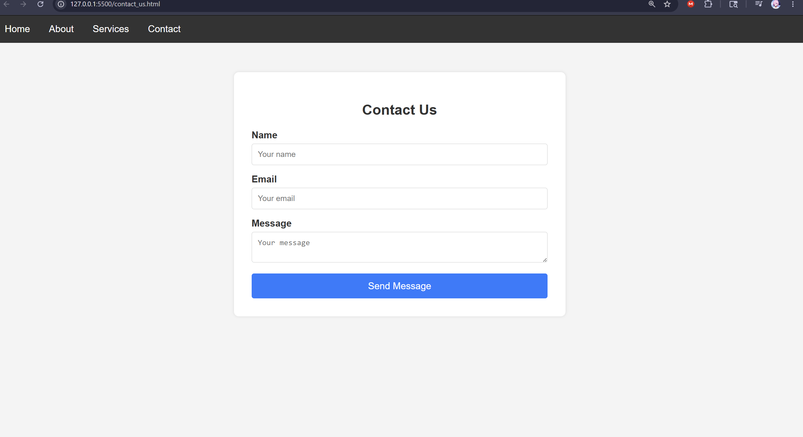

- image.html
